**KATEIKA: PILOTING HOME ECONOMICS IN THE EU PRIMARY SCHOOL CURRICULA PROJECT POST-TRAINING SURVEY EVALUATION: OMU FOUNDATION COLLEGE**

**BACKGROUND:**

The Japanese word kateika means “home economics”. It is a compulsory subject from primary to secondary schools that covers a comprehensive range of topics in Japan. At the primary school level, the overall objective of kateika education is to enable children to acquire the fundamental knowledge and skills necessary for everyday life, through practical and hands-on activities in the areas of family and family life, daily meals and basics of cooking, comfortable clothing and housing and daily consumption and environment according to the Ministry of Education, Culture, Sports, Science, and Technology (MEXT).[1]

For a long time, the aim of kateika has been for students to become independent in their daily lives. For example, cooking by themselves, washing clothes by themselves, and cleaning rooms by themselves, are the big aims for students because of necessity. Kateika has a suitable methodology for students to acquire those competencies across curricula.[2]

In this context, introducing kateika in European primary schools would allow the development of critical competencies that students will take in their lives. Learning to cook, clean and manage money are vital skills often overlooked, that should be the pivotal competencies for independent adults. Moreover, most of these skills are also connected to the current changes that we are seeing in society: learning to cook can also integrate competencies regarding food purchase, as well as sustainable consumption and production. The overall objective of the project is to “Develop key skills for independent and responsible adults in primary school students across the EU through the introduction of Kateika in the school curricula”. Therefore, the small-scale partnerships in school education KA210-SCH project proposal “KATEIKA: Introducing Home Economics in EU Primary School Curricula” was submitted by “Externo Paulo VI” school in Braga, Portugal with partners “Ondokuz Mayis University Foundation College” in Samsun, Turkiye, ‘’Ai Campi Elisi’’ in Trieste, Italy, “Arteteka” in Dublin, Ireland and “Hachinohe Gakuin University” in Hachinohe, Japan. It was accepted with project no 2022-1-PT01-KA210-SCH-000082859. After the online training session organised by Prof. Dr Yasuko Kato and Lecturer Hiroko Kawamorita from Hachinohe Gakuin University, the KATEIKA activities were organised by Portugal, Italy and Türkiye.

**ACTIVITIES AT OMU FOUNDATION COLLEGE:**

In accordance with the objectives of the project, four training courses were organised with around sixty students of the 6th-grade students of 6A, 6B and 6C Classrooms: A Cleaning and Keeping Organized Course, a Clothes Training Course, a Food Waste Management and Composting Training Course and a Preparation of Healthy Meal and Serving of Meal Course. Under the Cleaning and Keeping Organized Course, the participant students were trained to clean the classroom and organise their school lockers and bags. In the training course on clothes, we taught our students to button up a shirt, tie a shoelace, tie a necktie, fold the laundry, hang clothes on a clothes hanger, hang washed laundry, sort the laundry to be washed, sew a button, draw, paint and iron on t-shirts. With the training course on Food Waste Management and Composting Training, students learned how to separate waste, and we demonstrated them to make organic fertiliser from food waste with their active participation. In our final training course on the Preparation of a Healthy Meal and Serving of a Meal Course, the students were trained to make a shopping list, allocate a budget, do shopping, prepare healthy food, serve food, clear the table after the meal and wash the dishes.

**THE POST-TRAINING SURVEY ON THE TRAINING COURSES:**

To assess the outcomes and impact of the training courses, we conducted a post-training survey in the computer room of the College on June 8, 2023. We assessed the outcomes and impact of the KATEIKA activities based on a survey of 43 6th-grade students who attended home economics training. We analysed the answers to the questionnaire survey focusing on how the students felt they had gained competencies, skills and knowledge from the training courses, the increase of their awareness of the themes of the courses and their intention to use these competencies and knowledge in practice and future. There is a balance in gender among the participants. 21 of the 43 participants are female, and 22 of them are male.

Forms response chart. Question title: Your gender
. Number of responses: 43 responses.

**Chart 1: The Gender of the Students Who Attended the Training Courses**

The rate of the students who understood the purpose of the course is relatively high and this is a success of our project implementation.

Forms response chart. Question title: Did you understand the purpose of this training program at the beginning of the course?
. Number of responses: 43 responses.

**Chart 2: The Level of Students’ Understanding of the Purpose of the Course**

We also assessed the pre-training and post-training knowledge of the students and observed an increase in knowledge in all training activities.

metin, ekran görüntüsü, diyagram, öykü gelişim çizgisi; kumpas; grafiğini çıkarma içeren bir resim

Çok yüksek güvenilirlikle oluşturulmuş açıklama

metin, ekran görüntüsü, öykü gelişim çizgisi; kumpas; grafiğini çıkarma, çizgi içeren bir resim

Çok yüksek güvenilirlikle oluşturulmuş açıklama

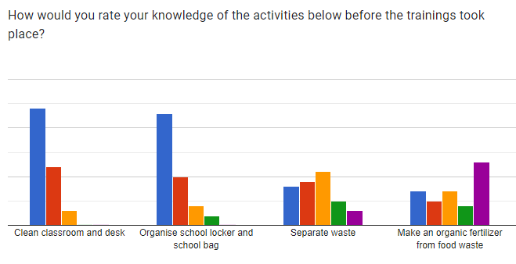

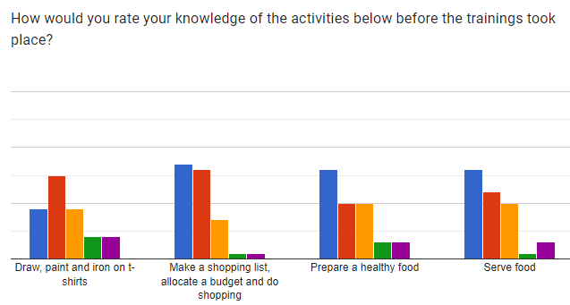

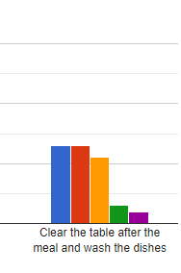

**Chart 3: The Rate of the Knowledge of the Students Before the Trainings**

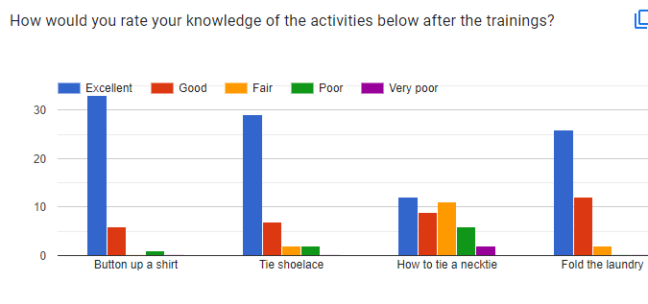

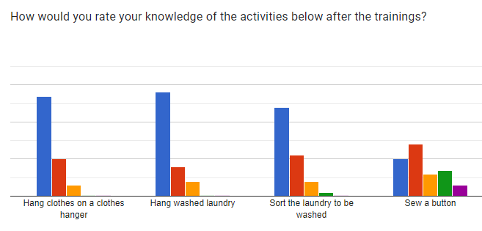

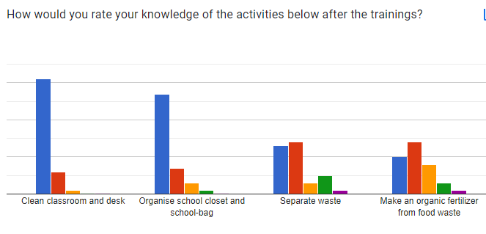

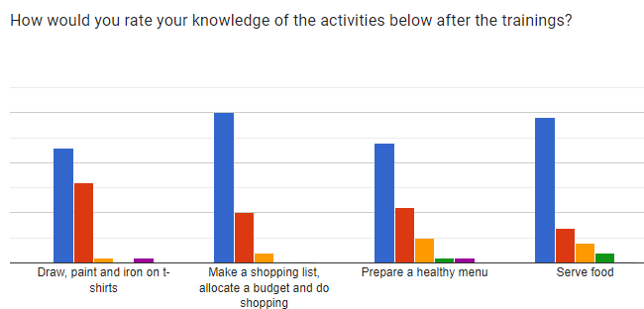

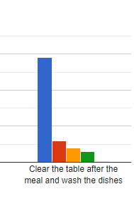

**Chart 4: The Rate of the Knowledge of the Students After the Training**

One of the essential findings of the survey is that the students claimed that they would retain the knowledge and competencies they have from the training. Only one student’s answer is no.

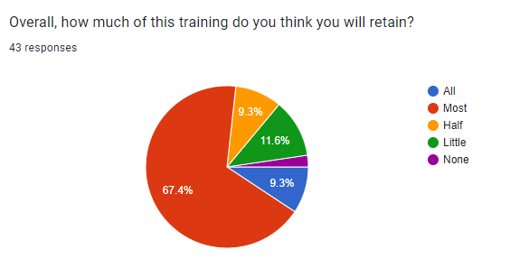

**Chart 5: How much the students will retain the training**

We also asked the students to what extent the training met their expectations, about the quality, duration, instructors and learning materials of the training. The rates of their satisfaction are very high.

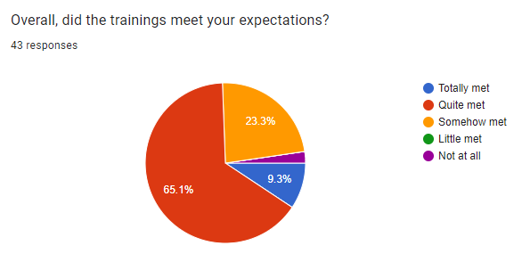

**Chart 6: The Expectations of the Students from the Training**

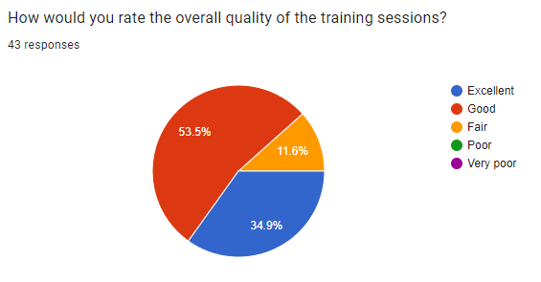

**Chart 7: The Quality of the Training Perceived by the Students**

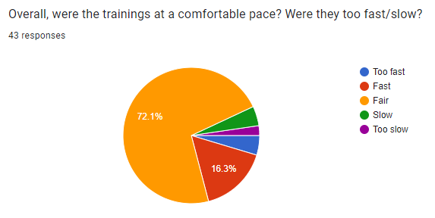

**Chart 8: The Pace of the Training Perceived by the Students**

Forms response chart. Question title: Overall, how would you rate the training instructors? Were the  instructors engaging and supportive? (Rate them as 5 is the highest and 1 is the lowest)
. Number of responses: 43 responses.

**Chart 9: The Quality of the Instructors of the Training Perceived by the Students**

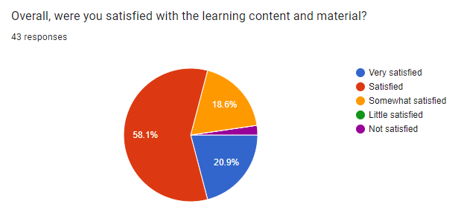

**Chart 10: The Quality of the Learning Content and Materials of the Training Perceived by the Students**

We also asked similar questions for each session of the training and observed similar results.

**RECOMMENDATIONS AND CONCLUSION**

The assessment of the training program is the last and the most significant stage of the training to understand the effectiveness of the training. Yet, only one assessment is not sufficient. The students can feel that they have acquired sufficient knowledge and skills in the short term after the training, but in the long term, they might lose some knowledge and competencies. Therefore, the periodical evaluation based on the surveys and semi-structured interviews is essential to assess the long-term impact of the training.

Another conclusion is that we observed that the students lack specific knowledge, competencies and attitudes to be independent citizens and adults in the future. One session of training has quite an impact on the knowledge, competency and attitudes of the students. In case a more systemic curriculum is needed to apply as it is in Japan and formal education is supported by informal and non-formal education and training, more component and knowledgeable societies can be built up with confident and independent citizens.

1. Ministry of Education, Culture, Sports, Science and Technology (MEXT) (2008a) ‘Course of Study: Home

   economics in primary school’. Online. www.mext.go.jp/component/english/__icsFiles/afieldfile/2011/03/17/

   1303755_009.pdf (accessed 12 July 2023).
2. Kawamura, M. (2016). Japanese home economics education ‘Kateika’: All children love it. Journal of the Japan Association of Home Economics Education, 59(1), 46–48.